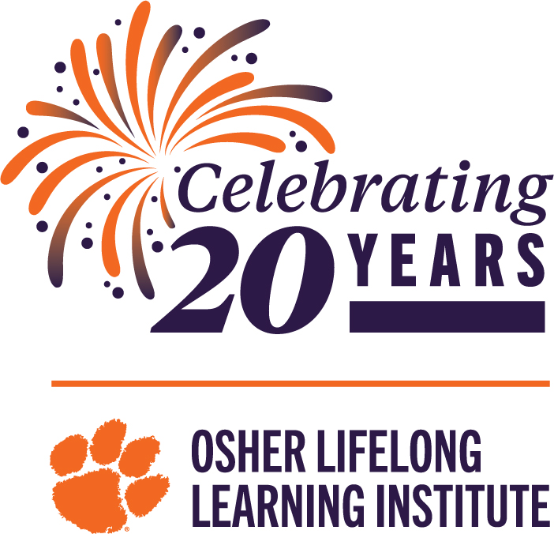

Title: OLLI Ambassadors

Purpose: To raise awareness in the community at large as well as to OLLI members about the organization, its mission, and the benefits it provides to members.

Duties:
- To become knowledgeable about the workings of the organization, how it fits within the Osher network of Life Long Learning Institutes, and the connection between this OLLI and Clemson University.
- To make presentations to groups/organizations describing what OLLI offers to its members in terms of educational opportunities in the form of classes, travel, discussion groups, special lectures, and the opportunities to participate in research projects being carried out at Clemson University.
- To organize and plan events to promote OLLI membership within the OLLI community
- To staff information booths at community events such as craft fairs, farmer’s markets, etc.

Time Commitment:
- To attend three Ambassador meetings per year.
- To work/participate in at least two events per year.

Resources:
- OLLI staff, CU interns, past members,
- Resource Notebook.
- Display materials, catalogs and various printed materials.
- Ready-to-go PowerPoint presentation supporting a 20- or 40-minute presentation.

Skills:
- The willingness to engage people and to tell them the OLLI story.
- Outgoing with good interpersonal skills.

